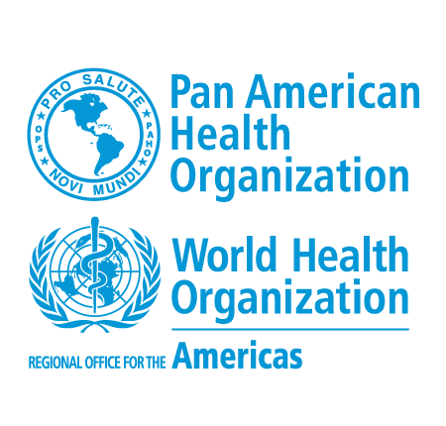

PERSONAL AND INSTITUTIONAL COMMITMENT LETTER

Dear Participant,

Welcome to the virtual courses offered by the Pan American Health Organization (PAHO/WHO) through the Virtual Campus of Public Health (VCPH). We appreciate your interest of participating in our courses.

In order to participate in this course, it’s necessary for you to have institutional support due to the relationship between the course contents and your responsibilities in your country.

The Virtual Campus of Public Health grants a limited number of places through the PAHO/WHO offices in your country. We would like to emphasize the commitment you assume with your institution, your country, and your PAHO/WHO office to meet the course requirements, complete it and to implement and disseminate the subjects learned in your work.

The courses are developed under a virtual mode centered on the reflection of the actual practice of each participant and are not self-instruction. Availability and a demonstrated commitment to devote a minimum of (8-10) hours per week of work for different synchronous and asynchronous activities of the course are required, meeting the deadlines defined in the schedule of the course.

In addition, participation in the course involves committing to:

- Reading various bibliographies;
- Individual and/or group activities and exercises;
- Participation in virtual exchanges (forums, Elluminate sessions, etc.); and
- Communication and continuous interaction with tutors and other students, following the schedule of activities.

To adequately meet the demands of the course is required to have a computer, permanent access and good internet connection, sufficient knowledge and proper handling in the use of software, tools and digital files (e.g. Microsoft Office), email, internet browsing and ease to print documents available electronically.

Failure of the course activities, the low participation and unexcused absences, will result in cancellation of enrollment in the course. Only in exceptional circumstances (illness, travel, etc.) and previous communication with tutor, academic coordination may consider extensions of deadlines and dates to meet course requirements.

Upon completion of the course, if you meet all requirements required, the CVSP will issue a Certificate of Approval, which will be sent via the PAHO/WHO country office for distribution and delivery. This process takes three to four months.

Then, we ask you to complete, print and sign this document (signature handwritten), put institution stamp, convert it into digital format and attach it to your application form. Without this requirement, you can’t be enrolled in the course.

PERSONAL AND INSTITUTIONAL COMMITMENT

Hereby, I (NAME OF THE UNDERSIGNED) certify that I have understood the above information and agree to comply with the requirements of the Virtual Course (NAME OF COURSE) and I reiterate my commitment about the performance that is expected in this course.

On behalf of my institution, (SUFFIX, FIRST AND LAST) who holds the position of (TITLE OF OFFICE) at (NAME OF INSTITUTION AND DEPARTMENT LABOR), reaffirms the institutional commitment of providing the necessary facilities and time to meet the academic requirements of this course.

Done in the City of (CITY), (COUNTRY) on (DATE).

PARTICIPANT SIGNATURE INSTITUTIONAL REP. SIGNATURE
(Signature) (Signature)

